

**Week 4:** Deployment on Flask

**Name:** Madhvik Bhalani

**Batch code:** LISUM32

**Submission date**: 09 May 2024

**Submitted to:** Data Glacier

**1. Implementing Classification Model**

**Step 1:** Data Preprocessing

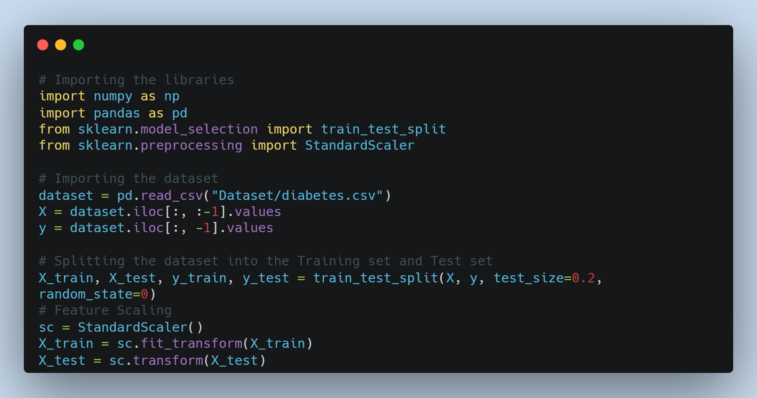

**Step 2:** Implementing Logistic Regression

After thorough experimentation with various models, I've chosen to present the Logistic Regression Classifier here because of its highest accuracy.

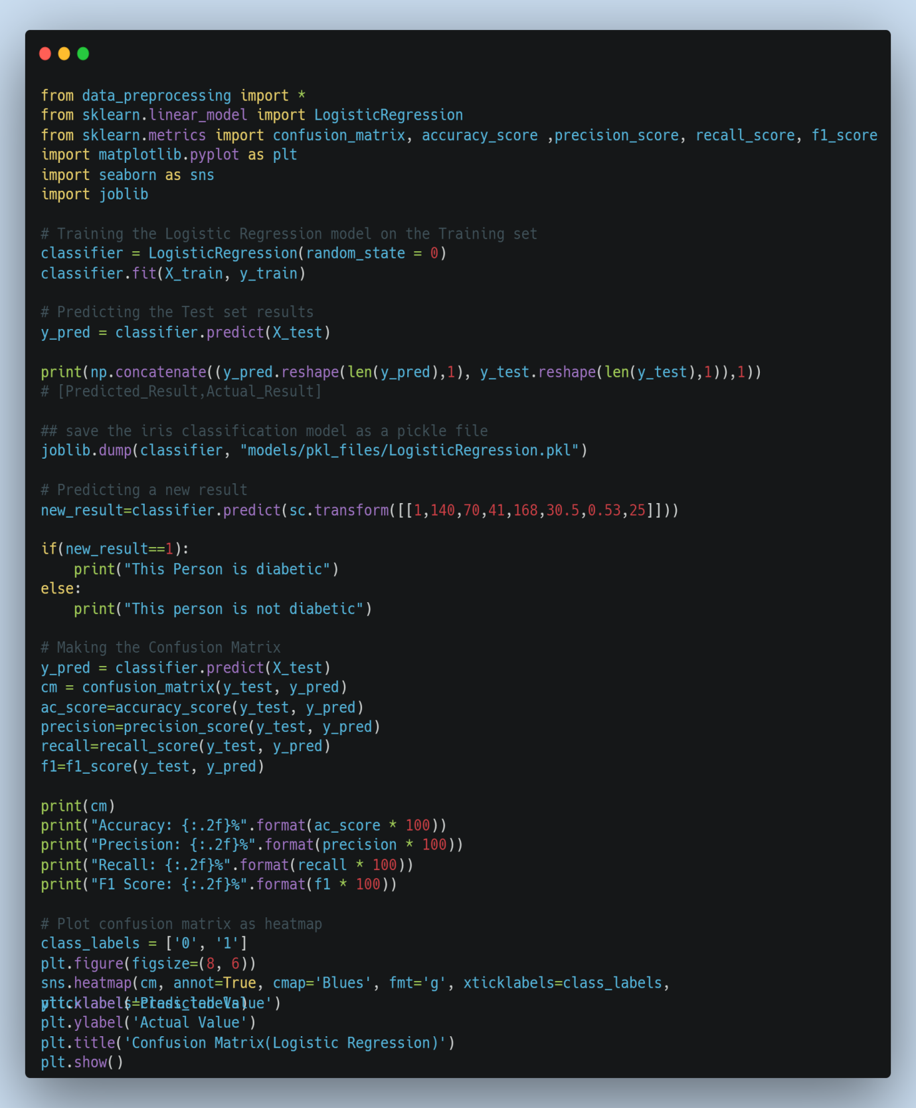

**2. Flask App Development**

**Step 1:** Create and Setup Flask App

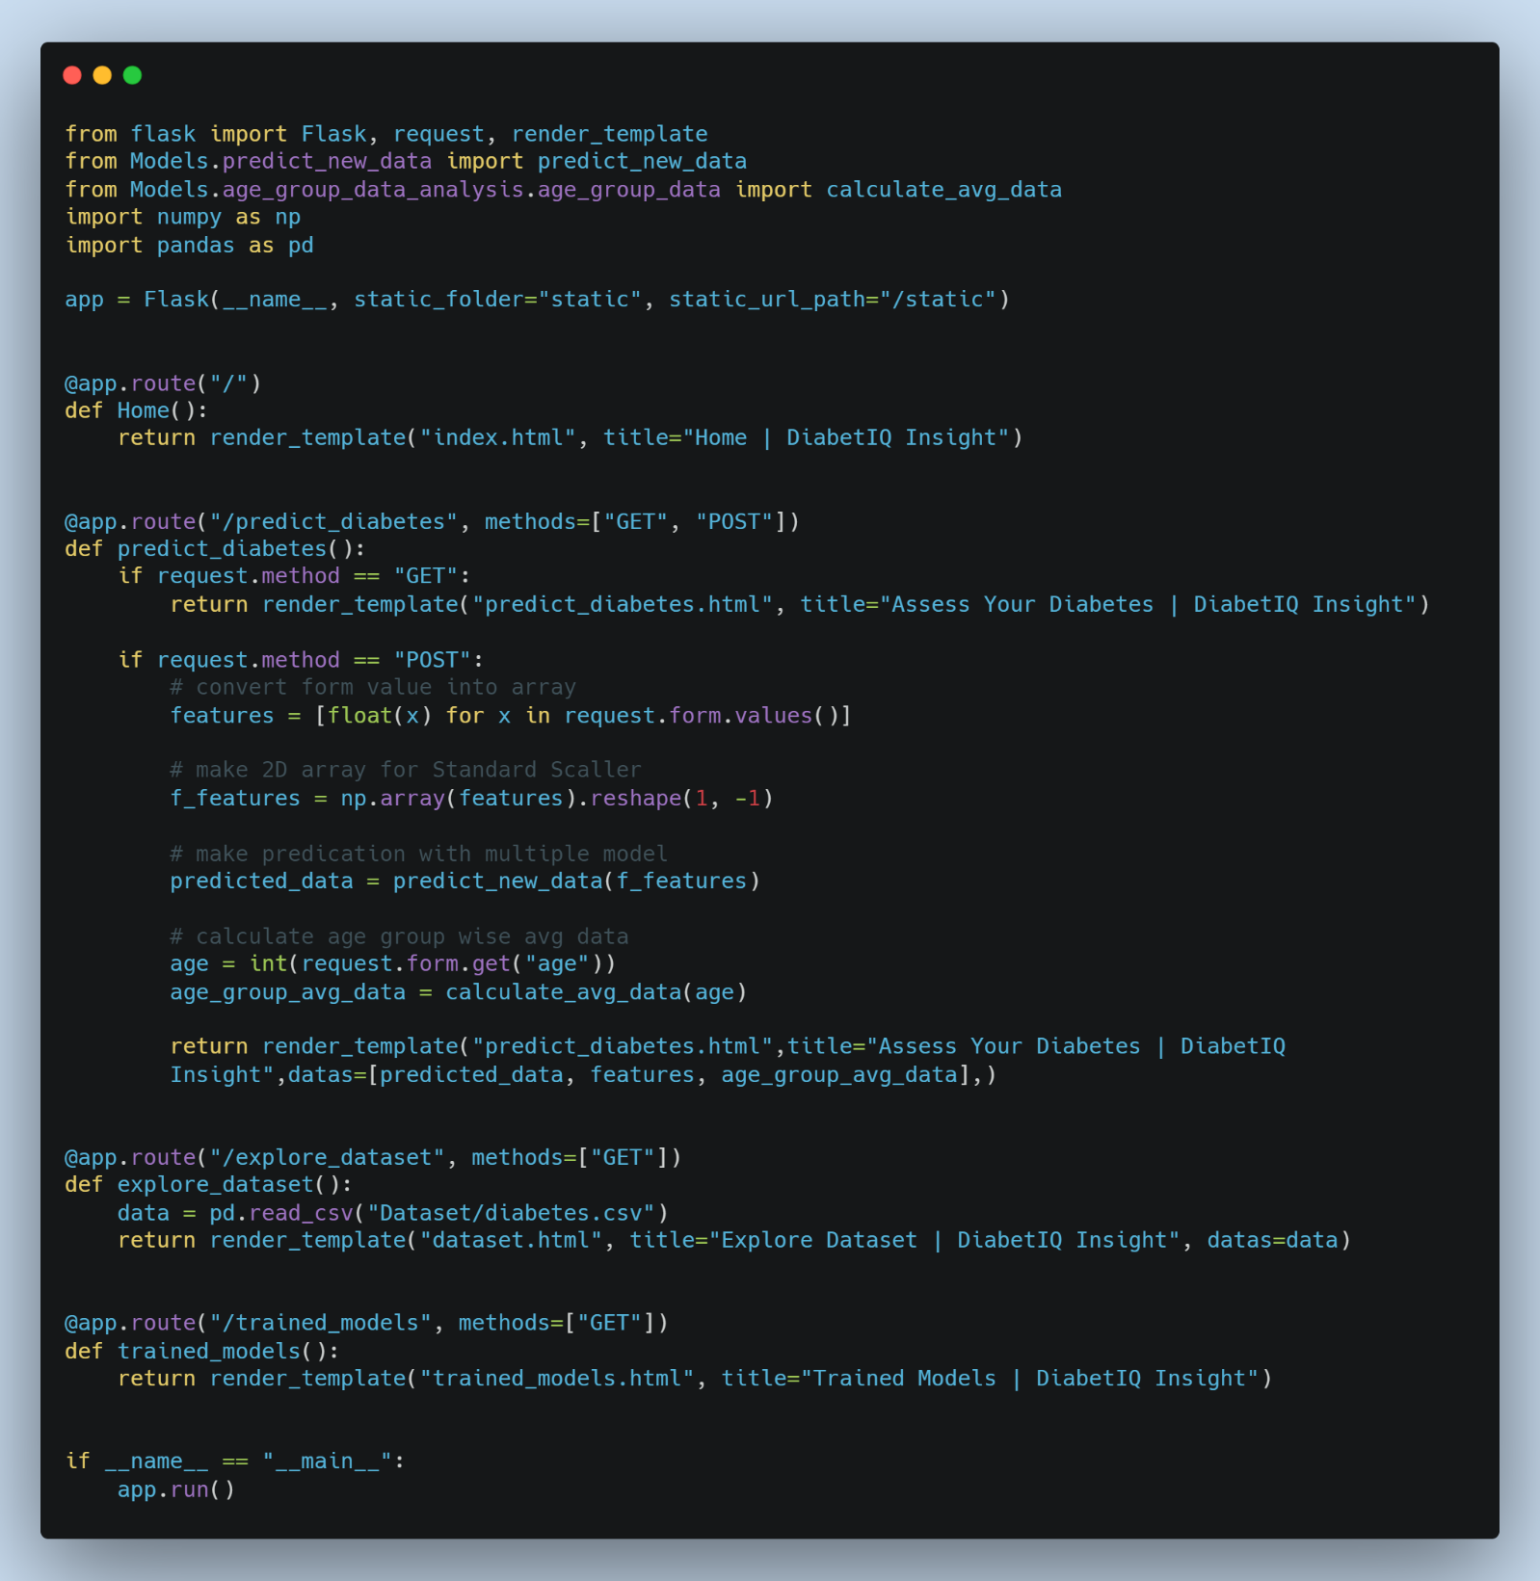

**Step 2:** Create Base Template for Web App

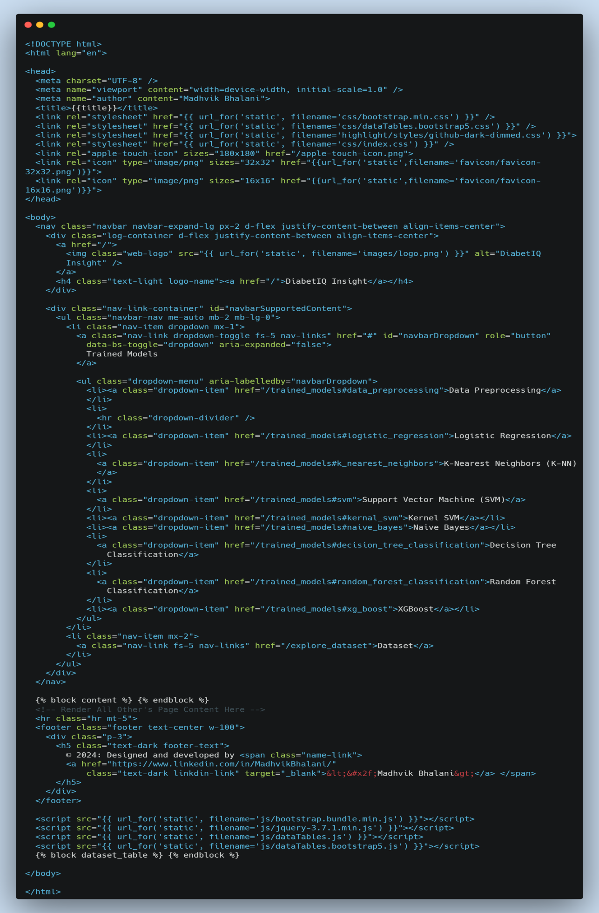

**Step 3:** Create Home Page

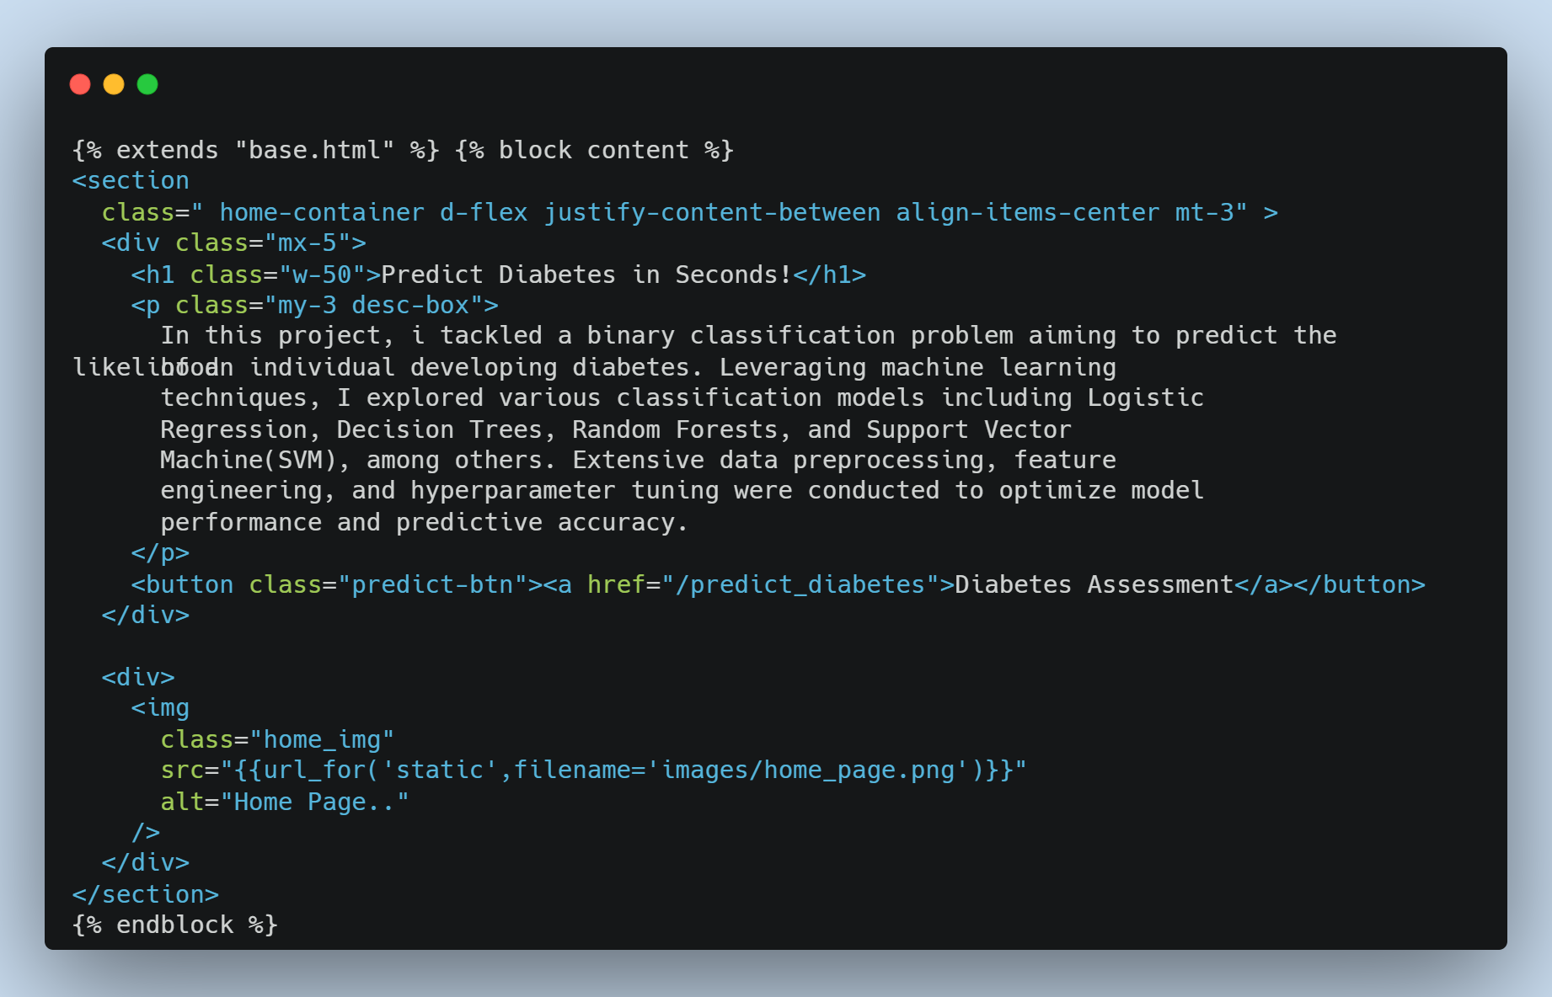

**Step 4:** Create Web Form for Input Data

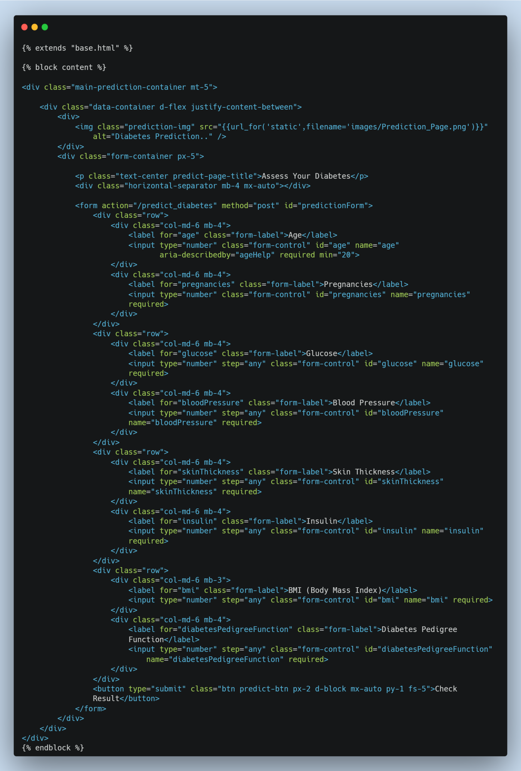

**Step 5:** Visualize Prediction

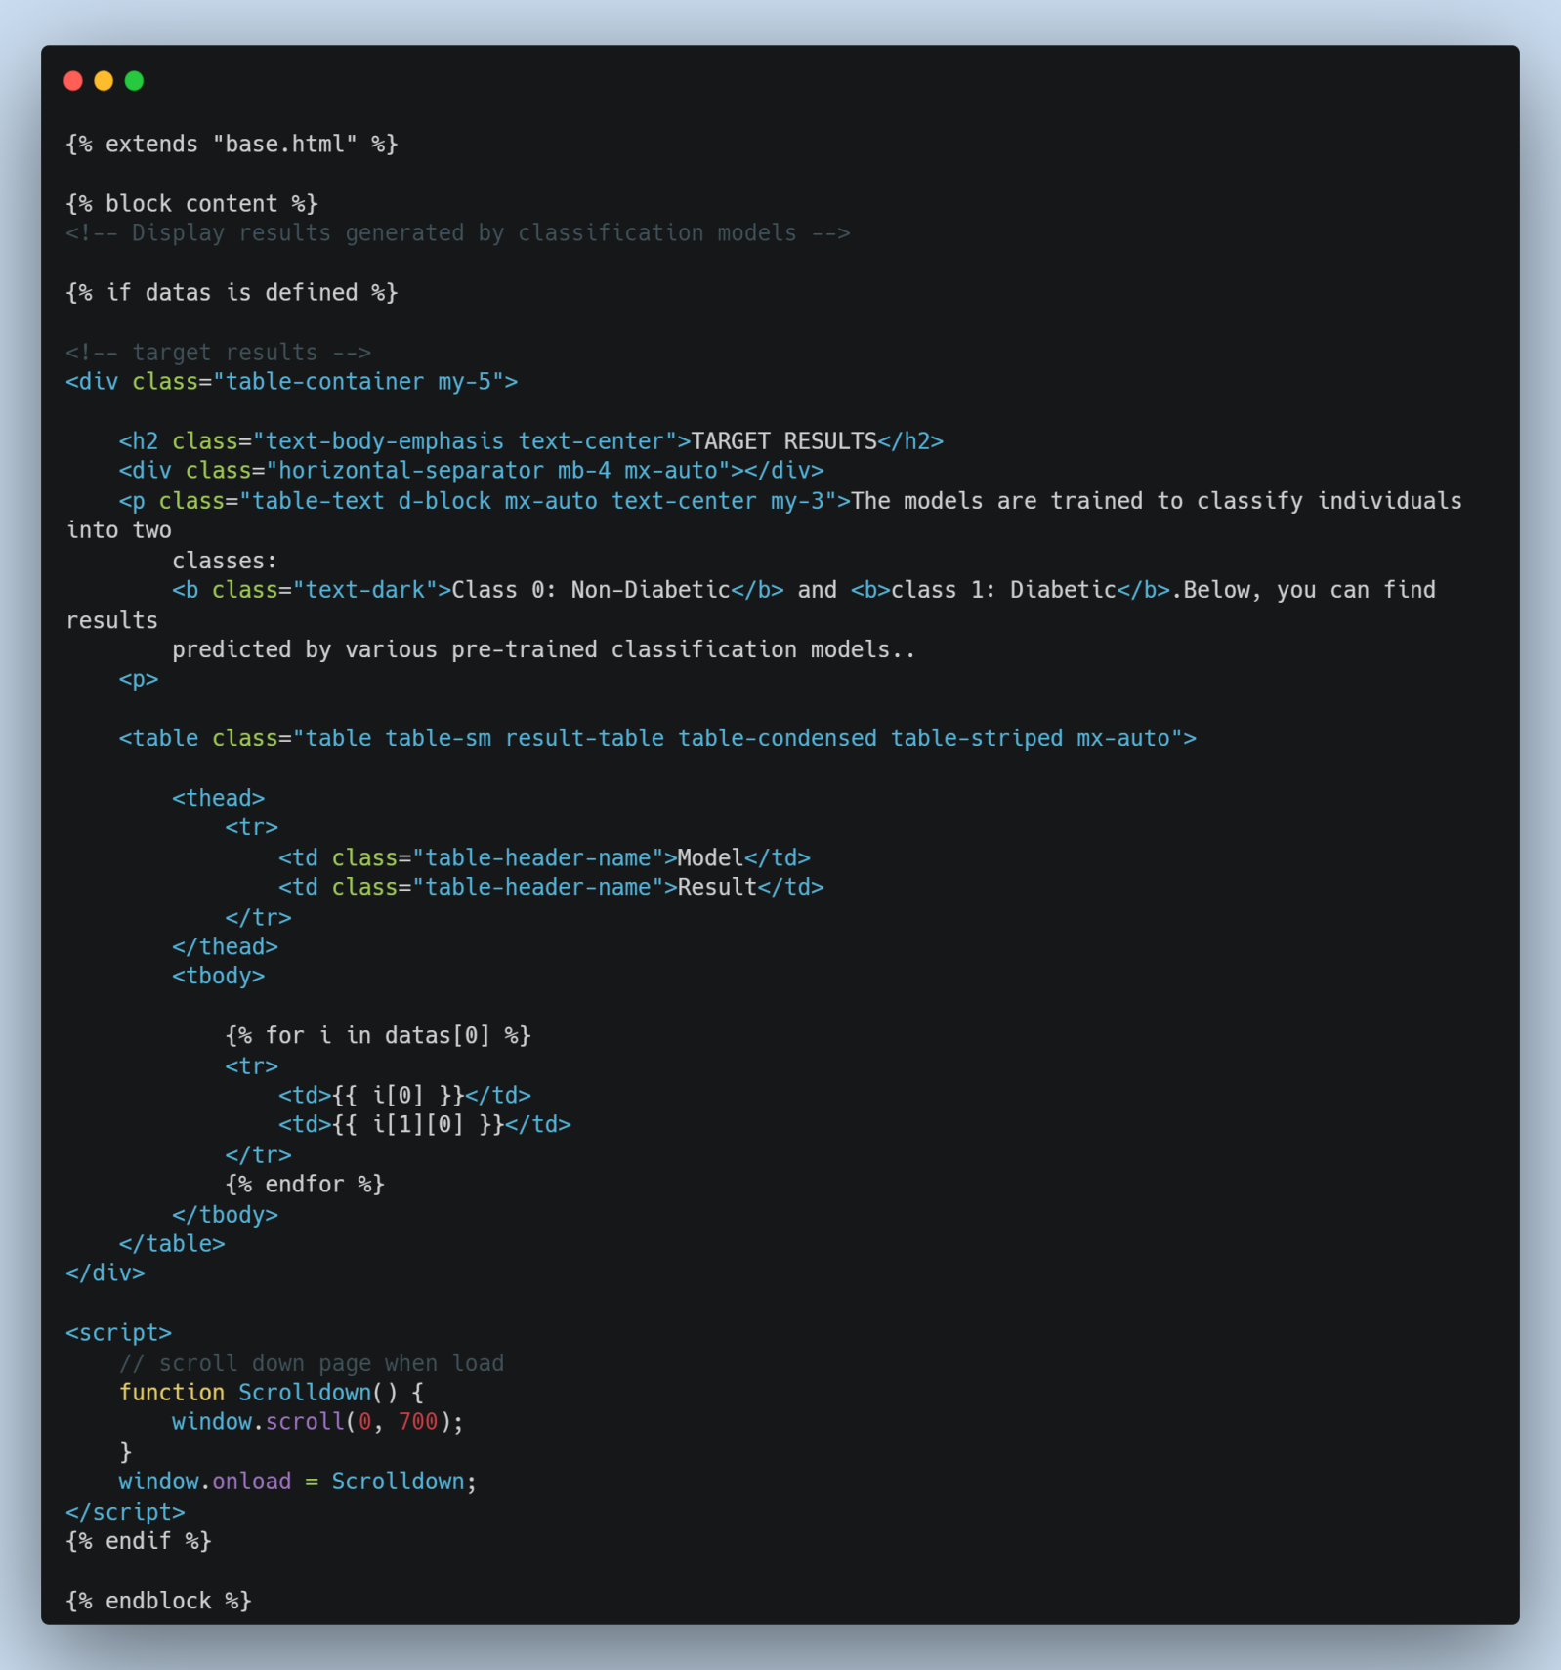

**Step 6:** Visualize Age Segmented Health Metrics

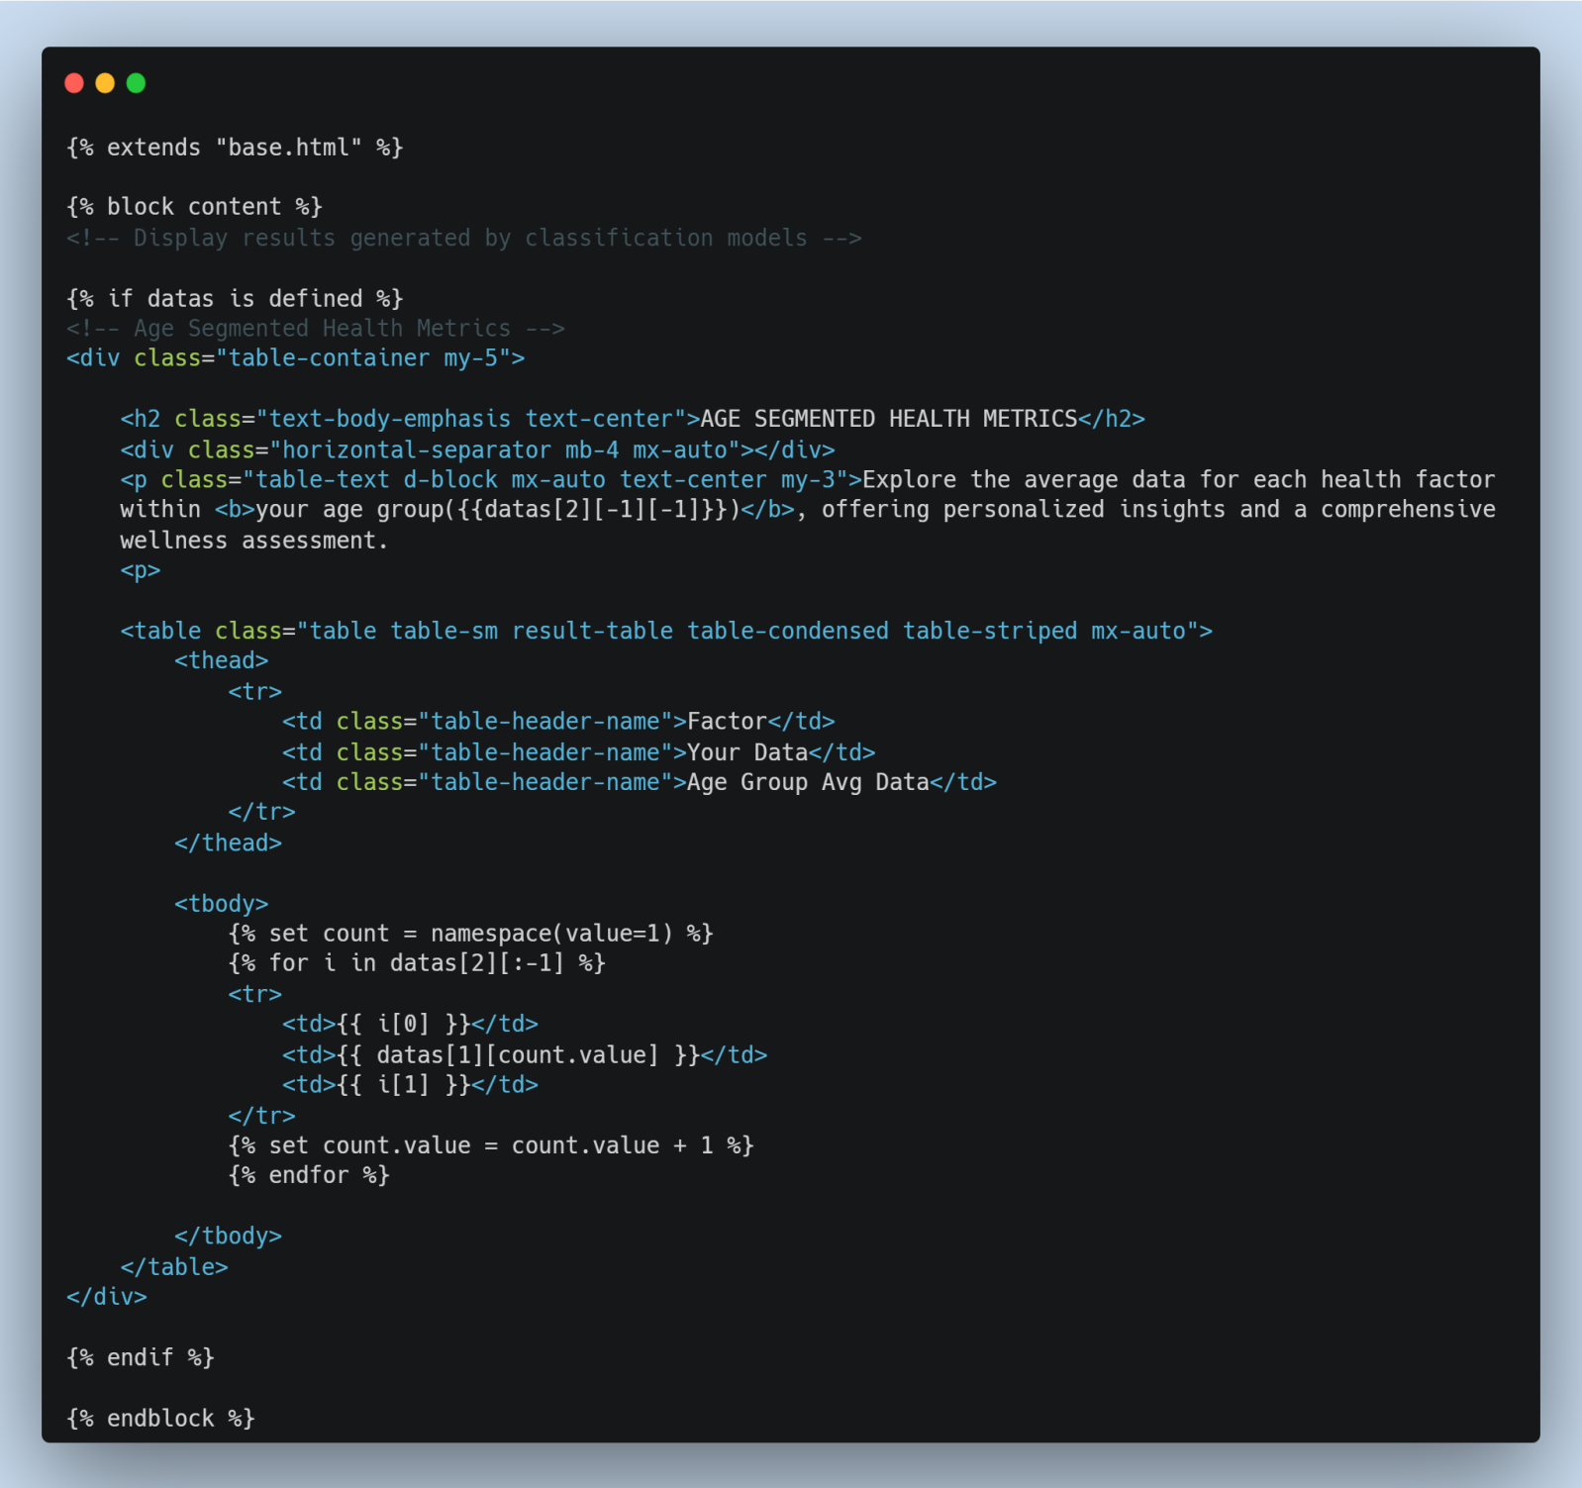

**Step 7:** Visualize Dataset

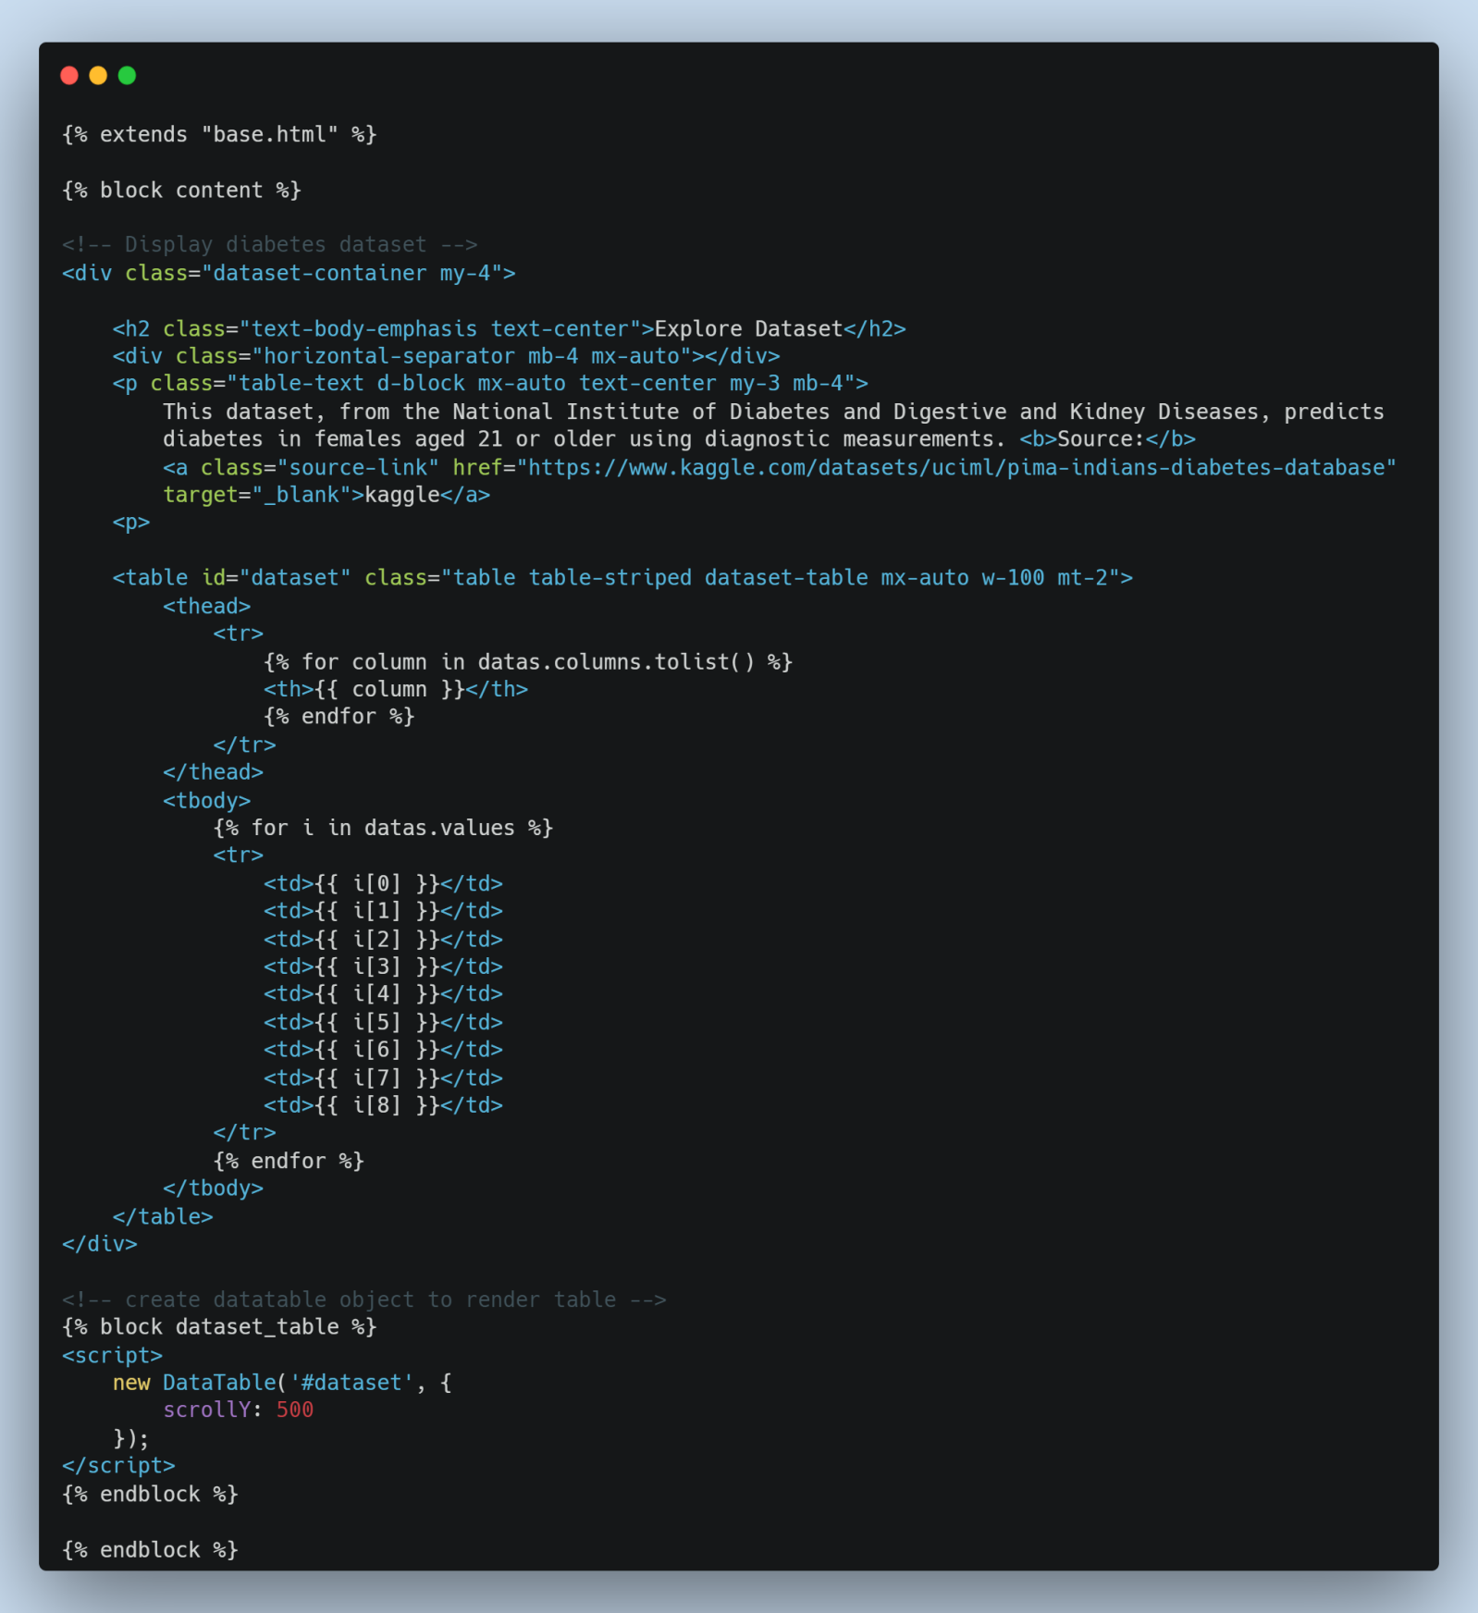

**3. Snapshot of web page**

**i. Home page**

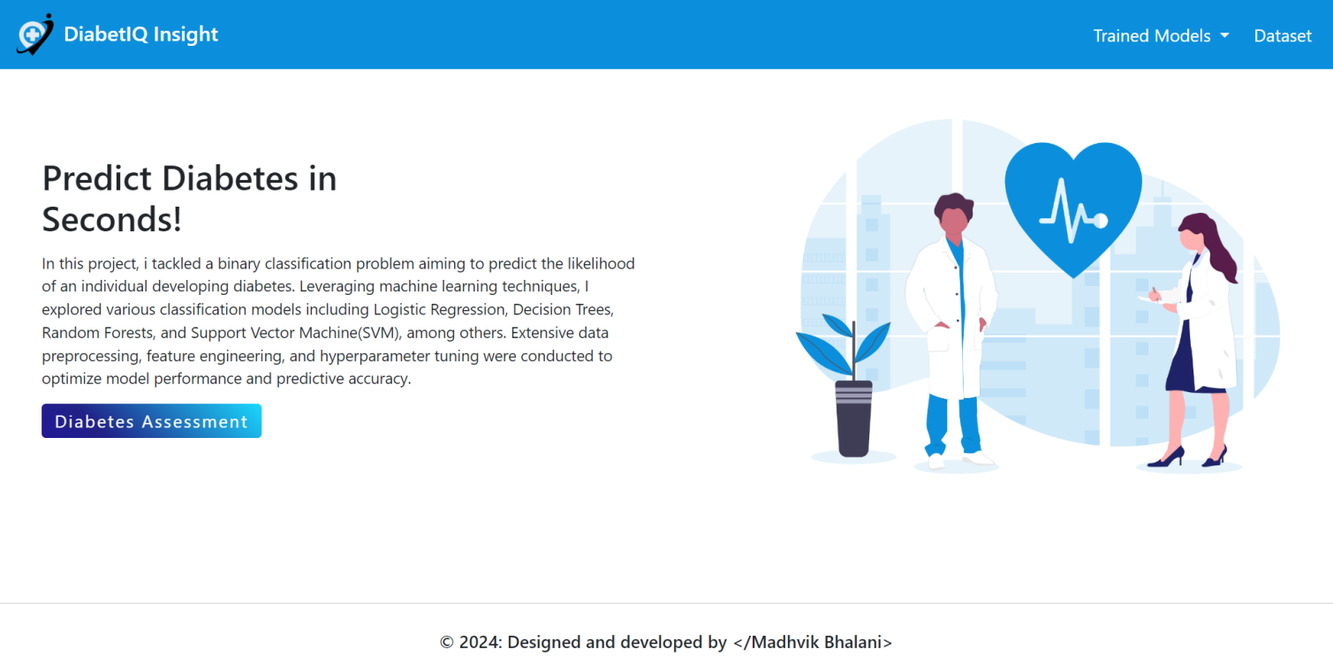

**ii. Diabetes Prediction form**

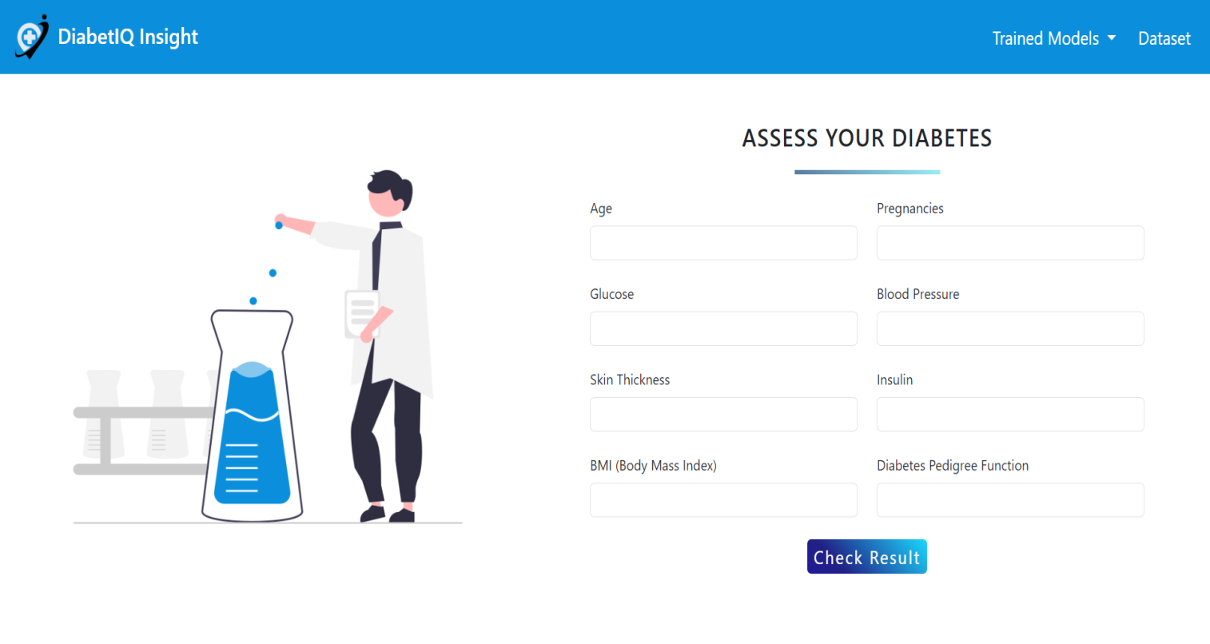

**iii.** **Predicted Result and Age Segmented Health Metrics**

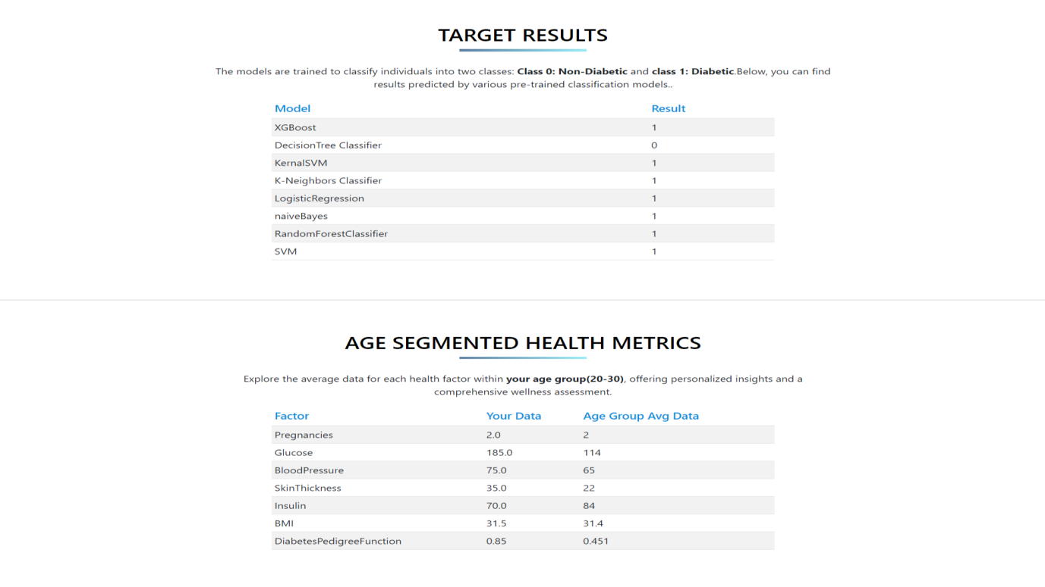

**iv.** **Model data**

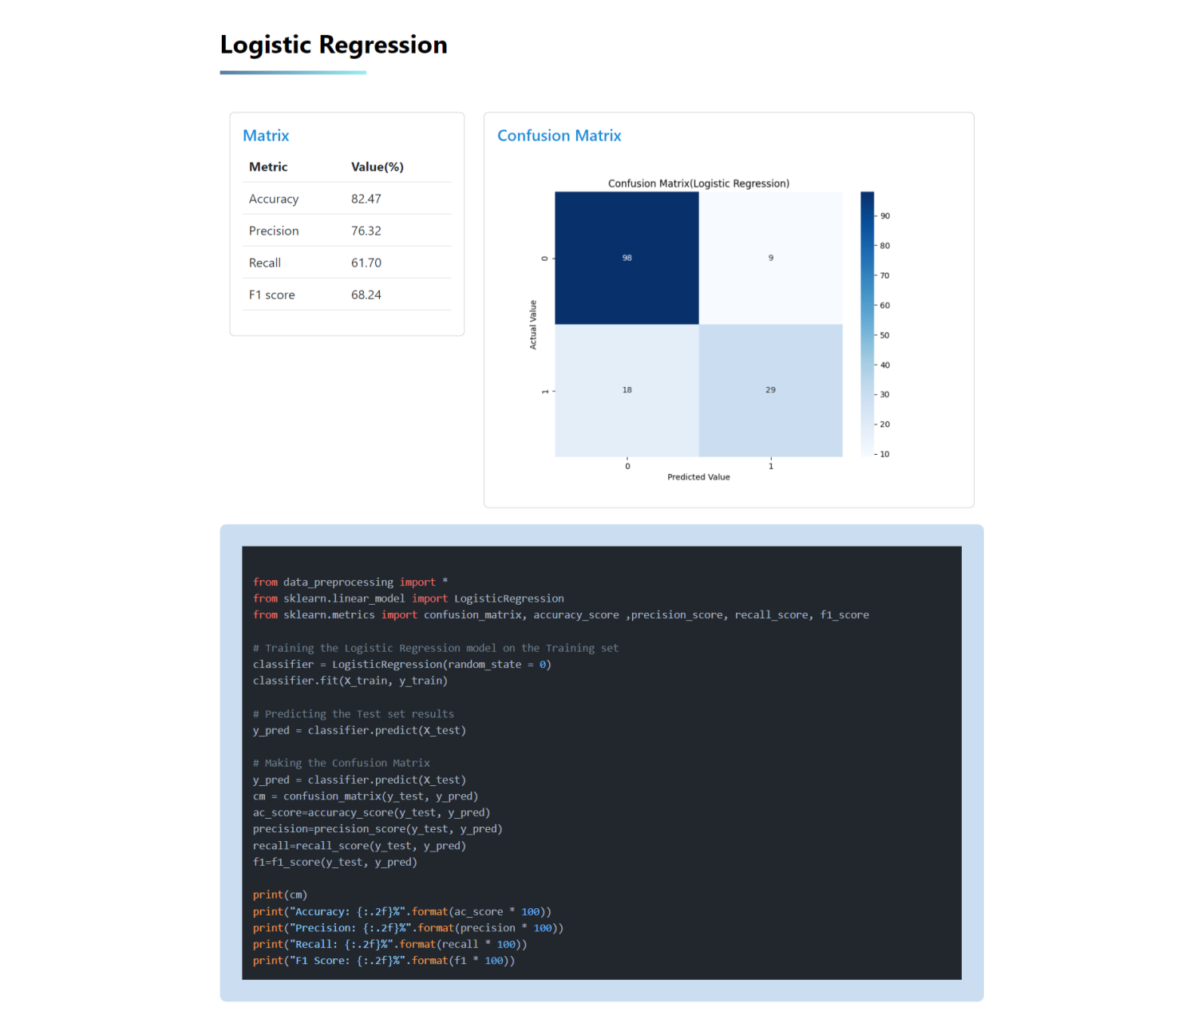

**v.** **Dataset**

